Wine Cooler
JC-201
Instruction Manual
VI 59177 FS BK

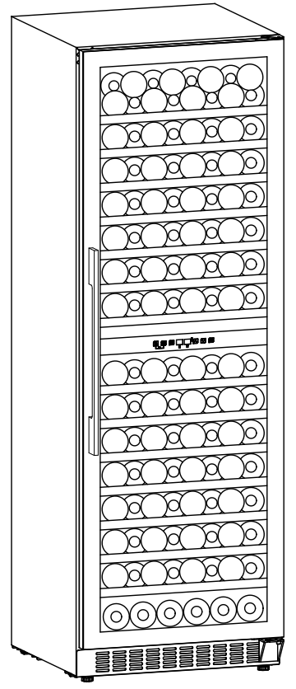

NOTE: Thank you for your purchase and use our compressor wine cooler！This product is used to chill red wine.
Our product will create perfect temperature and humidity environment to store your collection of wine quietly and peacefully.

Content
Safety instructions & warnings………………………………..…………………………….1-6

Installation………………………………..……………………………………………………………7

Description of the appliance………………………………..…………………………………8-9

Operation………………………………..……………………………………………………………..10-12

Troubleshooting………………………………..…………………………………………………..13

Maintenance and cleaning………………………………..…………………………………..14

Technical parameters………………………………..…………………………………………..15

Safety instructions & warnings
Your safety is of the utmost importance to our company. Please make sure that you read this instruction booklet before attempting to install or use the appliance. If you are unsure of any of the information contained in this booklet, please contact the Technical Department.
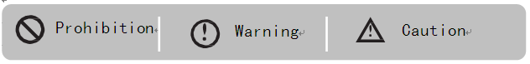


- This appliance can be used by children aged from 8 years and above and persons with reduced physical, sensory or mental capabilities or lack of experience and knowledge if they have been given supervision or instruction concerning use of the appliance in a safe way and understand the hazards involved. Children shall not play with the appliance. Cleaning and user maintenance shall not be made by children without supervision.
- Children aged from 3 to 8 years are allowed to load and unload refrigerating appliances. Children should be supervised to ensure that they do not play with the appliance.
- This appliance is intended for HOUSEHOLD USE ONLY and not for commercial or industrial use.


- Keep ventilation openings, in the appliance enclosure or in the built-in structure, clear of obstruction.
- Do not use mechanical devices or other means to accelerate the defrosting process, other than those recommended by the manufacturer.
- Do not damage the refrigerant circuit.
- Do not use electrical appliances inside the storage compartments of the appliance, unless they are of the type recommended by the manufacturer.
- Make sure that the appliance is connected to power supply in accordance with the rating label.
- Use an independent grounded socket with 10A or higher, do not connect to transformer or socket with multiple outlets.
- Make sure socket is grounded properly and do not modify power cord & plug.
- Connect power plug with socket firmly in case of possible risk of fire.
- Plug should be within reach for easy disconnection after the appliance positioned in case of accidents occurred.
- Do not store or burn gasoline or other inflammables near the appliance in case of possible fire.
- Do not store inflammables, explosives, acid & alkaline liquids etc.in the compartment of the appliance.
- Do not operate other appliances in the compartment.

Child Safety
- Do not allow child play inside the appliance in case of entrapment.
- Do not allow child hang on the door to play in case of falling of the appliance.
- Do not allow child reach into compressor compartment or touch metal components at rear of the appliance in case of possible injury.

Keep away from water
- Do not spray water on the appliance or wash the appliance by pouring or filling water in case of invalid insulation and possible electric shock.

Be careful of freezing
- Do not touch surface of the liner inside the compartment, especially with wet hand, in case of frozen injury while the appliance is in operation.

Do not open the door for long periods
- Opening the door for long periods can cause a significant increase of the temperature in the compartments of the appliance.

Modification on the appliance not allowed
- Do not reconstruct the appliance by yourself which might cause damages to the appliance.

Unplug the appliance under certain conditions
- Unplug the appliance before cleaning & maintenance.
- Unplug the appliance when power cut occurred.

Disposal of the appliance
- Please according to local regulations regarding disposal of the appliance for its flammable refrigerant and blowing gas.
- Before you scrap the appliance, please take off the doors to prevent children trapped.
- Send the appliance to the designated disposal location.

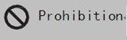
Do not damage the power cord
- Do not disconnect the appliance by pulling power cord rather than pulling the plug.
- Do not set the appliance above the power cord or step on the cord intentionally.
- Put the power cord at right place when moving the appliance.

When the power cord is damaged
- Do not use damaged power cord, and get it replaced immediately by manufacturer service agent or by qualified electrician.
- If needed, extend the power cord with cord of 0.75mm2 or bigger by qualified electrician.

Installation
Position
Do not lean the appliance over 45°when moving it to position.

The appliance must be put on flat,firm & dry floor or similar noncombustible pad; do not use the package foam pad.
酒柜结构及安装示意图
Do not put the appliance in the wet place.

Do not use the appliance in the frozen place.

Do not use the appliance outdoor in case of sunlight or rain.

The appliance must be set with 10 cm wider space around for good ventilation; it is normal for the housing of the cabinet getting heat when it’s in operation.

The appliance is designed to either build in the cabinet or stand alone on the floor.

Demonstration for building in the cabinet:
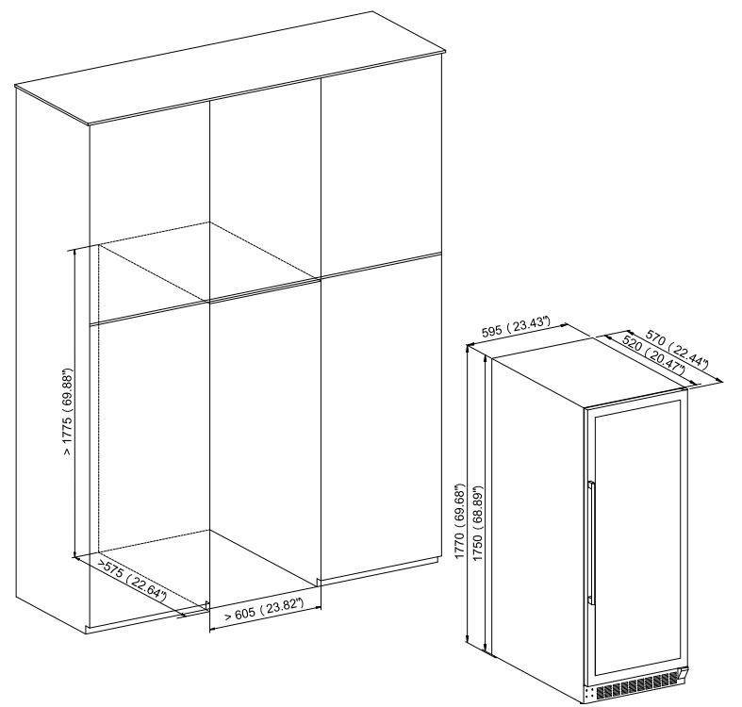
Wine bottles can be stored when it feels cool inside, and only after the appliance has been on around 1 hour.
Description of the appliance
Overall image
13. Upper hinge

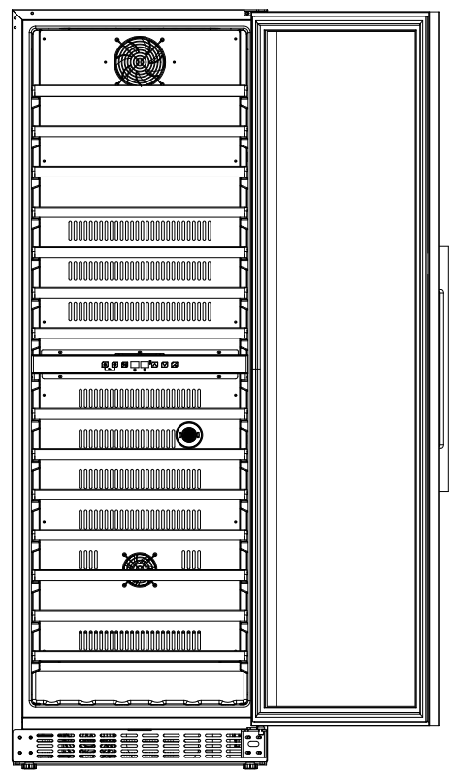
2. Shelf
3. Control panel
4. Cover board
5. Fan
7. Adjustable foot
8. Lower hinge
9. Door
11. Handle
12. Door seal
6. Grille
10. Carbon filter
- Housing

Note:
Shelves, door frame, handle and other accessories could be different according to different models and configuration.
All photos in this manual are for reference. The appliance you buy might not be exactly the same as shown here.
Please refer to the actual product.
Replace carbon filter
- Rotate the carbon filter② left or right to the gap of ①（Ear positions on both sides of the circumference） and take it out.
- Insert the carbon filter② along the gap and rotate it in the left or right direction. Once it feels like it cannot be rotated, the installation is completed.
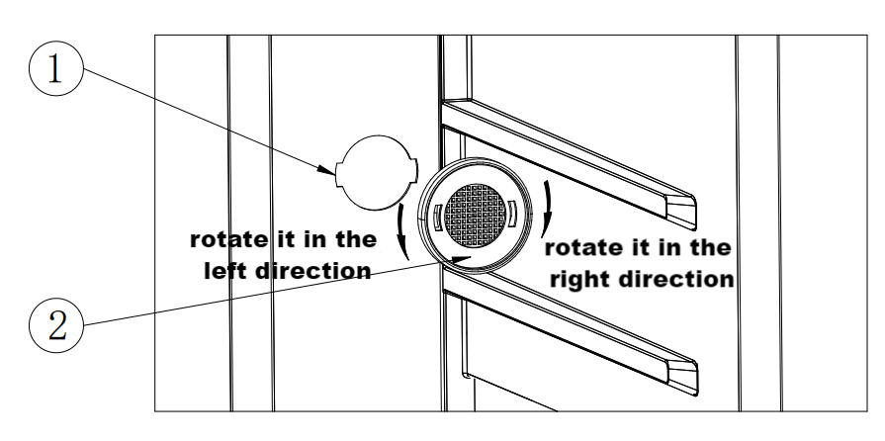

Installing handle and reversing the door
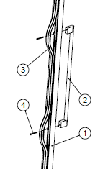
- Install handle to the door frame of the appliance.

The handle is delivered in a separated package with screws together inside the carton.

① Reveal two small holes on the door frame from inner side by pulling out a bit the door seal ② Aim the handle to the holes and insert the screws from inside ③ Screw them up with screw-driver ④ Put back door seal to cover the screws.

- Reversing the door
Our wine fridge is delivered with the door opening from left to right. To reverse the opening direction:
- Open the door at 135 degrees and keep it steady. (be careful that the door is tall & heavy)
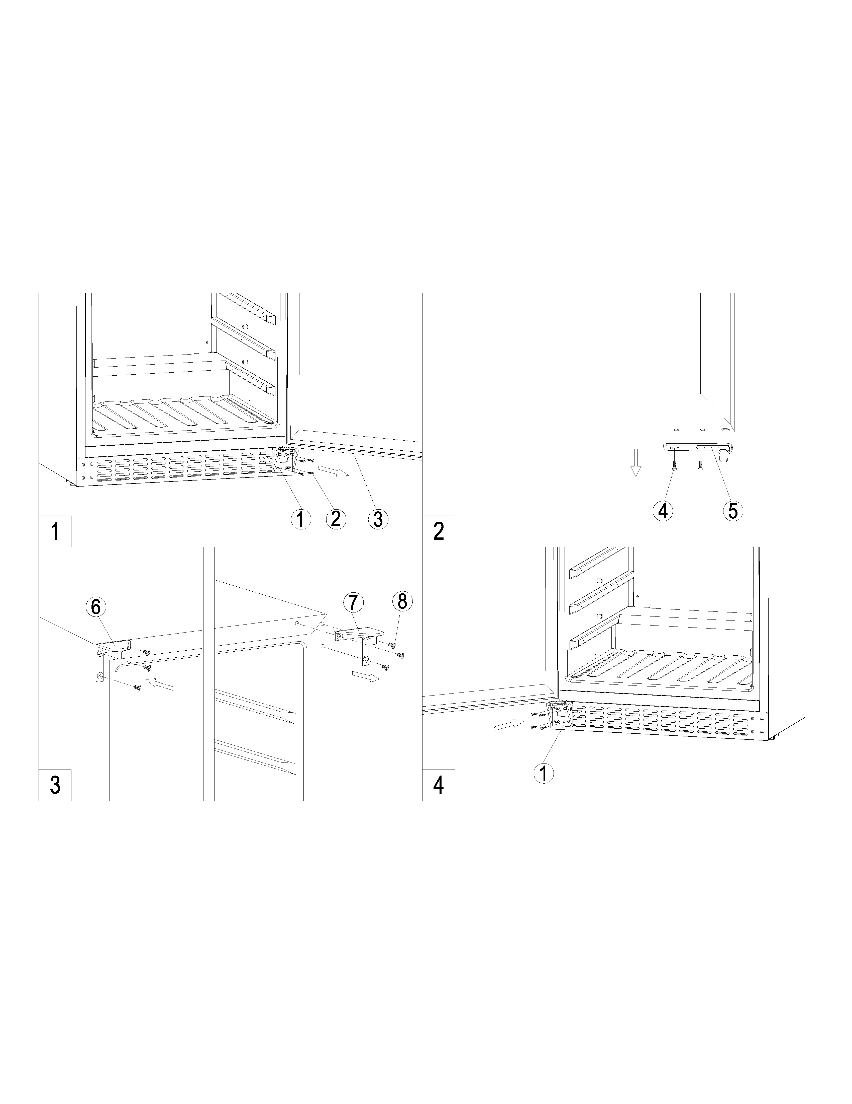
- Unscrew the four screws ② from the lower hinge ① [Figure 1].
- Pull the door outwards slowly [follow the arrowhead direction in Figure 1] to get off the lower hinge ① and continue to pull the door downwards slowly until getting off from the top right hinge, and unscrew the two screws ④ to take off the lower hinge plate ⑤ from the door [Figure 2].
- Screw top right hinge ⑦ off from the cabinet and keep it in the polybag for needs if you want to change back left opening door in the future.[Figure 3]
- Install the top left hinge ⑥ & the lower hinge ① to the left side of the cabinet.( ⑥ is delivered in a separated polybag inside the packing carton).[Figure 3]
Turn the door 180 degrees upside down and fit the top door axis hole to the top left hinge ⑥ and put lower hinge plate ⑤ on the lower hinge ① and keep the door steady to screw the lower hinge plate ⑤ with the left bottom door frame. [Figure 4] Door reversing is finished.

Operation
Start operation
1. Cleaning the compartment
Before power on, clean inside of the appliance and check the drainage pipe in good connection.（For details, please refer to the “Maintenance and cleaning”）
2. Placement
Before powering on, level the appliance on the firm & dry floor for at least 30 minutes.
3. Power on
The appliance start operation and it will cool down inside after 1 hour, otherwise you should check the power connection.

Control panel
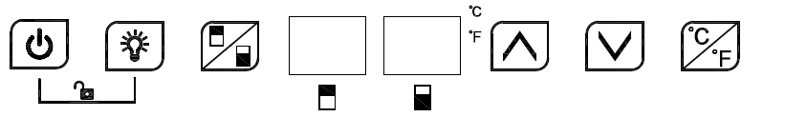

All keys would be invalid if in lock mode. Please unlock first.

 ON/OFF
1. Keep pressing the key 3 seconds, power down, goes to stand-by mode.
2. Keep pressing the key again 3 seconds to return back to normal working.

 Light
Press the key, turn on or turn off the LED lights inside. In stand-by mode, the key is invalid.

Zone switch
Press the key to switch between upper zone and lower zone for choosing which zone to set temperature. Press the key once, the LED display in chosen zone flash regularly. Press up and down key to set temperature. Press the key again; switch to other zone to set temperature.

 UP
Press the key once, LED Display in regular flash showing current set temperature. Continue pressing to adjust set temperature, one press increase 1℃. Regular flash quit after 5 seconds detecting no press and new set temperature saved. LED display return to show actual temperature inside.

Down
Press the key once, LED Display in regular flash showing current set temperature. Continue pressing to adjust set temperature, one press reduce 1℃. Regular flash quit after 5 seconds detecting no press and new set temperature saved. LED display return to show actual temperature inside.

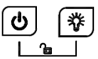Child Lock（Combination key）
1、Lock：Press both keys at the same time for 3 seconds to lock.
2、Unlock：Press both keys at the same time for 3 seconds to unlock.

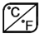Fahrenheit/Celsius display interchange
Switch temperature display between Fahrenheit and Celsius by pressing and holding the key for 2 seconds.

Attention
- For both upper and lower zone, the cooling temperature could be set from 5℃ -22℃. But lower zone temperature will equal to or be higher than upper zone.
- Alarm sound: when the system malfunction occur and alarm sound, press any key on the control panel to cancel the alarm sound.
- Error code:
When the temperature sensor of upper zone failure occur, error code displays: E1 for open circuit; E2 for short circuit.
When the defrost sensor failure occur, error code displays: E3 for open circuit; E4 for short circuit.
When the temperature sensor of Lower zone failure occur, error code displays: E5 for open circuit; E6 for short circuit.

Wine storage
- The appliance is equipped with sufficient shelves to allow your collection of wine get mature quietly and peacefully.

- 14 wooden shelves loading capacity: 126 bottles. (standard Bordeaux with 750ml )
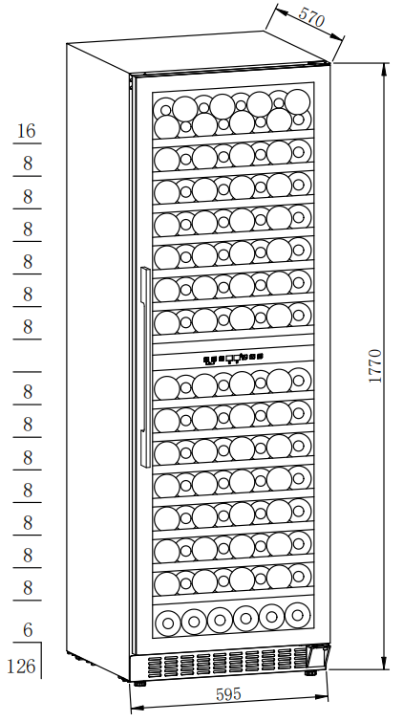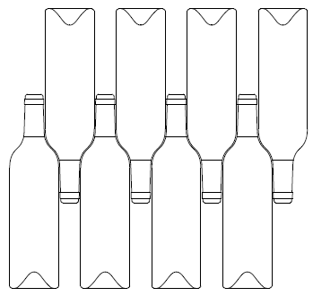
- Loading capacity will vary in terms of different way of bottle arrangement or different bottle sizes.

- Each shelf is designed to put on 1 or 2 layers of wine bottles. More than 2 layers of bottle arrangement on one shelf are not recommended.

- Each shelf with sliding roller could pull out partly to store wine bottles easily.

- Open the door straight enough before pulling out shelves.

- If the wine cooler would have no load for a long time, it is recommended to power it off, clean it carefully, and open the door for ventilation.

- Below table is the recommended temperature for wine storing & drinking:

Red Wine | 15-18℃
White Wine | 9-14℃
Rose wine | 10-11℃
Champagne & sparkling wine | 5- 8℃

Troubleshooting
The appliance makes lots of noise? | - Please adjust the front foot, keep the appliance leveling.  - Please keep the appliance a bit space from walls.
Liquid flowing sound inside the cabinet? | - It is normal because of the refrigerant working inside.
The appliance does not start? | - Make sure the appliance is connected to the power properly.  - Make sure switch on the power.  - The compressor re-starts after 5 minutes for a power cut.
Compressor runs continuously? | - If no cold is being produced, call the retailer’s after-sale service.
Door does not seal tightly? | - After long time use, the door seal might get stiff & distorted partially.  - Heat the door seal with hot-wind blower or hot towel.  - The door seal get softened and close the door.
The appliance does not cool sufficiently? | - Please adjust temperature setting.  - Keep the appliance away from sunlight or heat.  - Please do not open the door frequently.
Unpleasant smells inside cabinet? | - A little bit plastic smell for newly-buy appliance is normal and will disappear after a short time.  - Clean the compartment and ventilate it for a few hours.
Condensate on the glass door? | - Please do not open the door frequently or for a long time.  - Please do not set the temperature too low.  - High ambient temperature and humidity would cause condensate.
The light is not working? | - Check the power supply first.  - Call the retailer’s after-sale service if the light is broken.

Maintenance and cleaning
Cleaning
- Disconnect the appliance before cleaning.
- Clean the appliance with soft cloth or sponge by water.
- Do not use organic solvents, alkaline detergent, boiling water, washing powder or acid liquid etc.
- Do not flush the compartment of the appliance.
- Clean regularly surfaces that can come in contact with accessible drainage systems.

The below items will damage the surface of wine cooler:
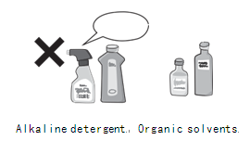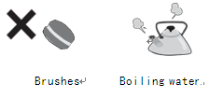

Power cut
Most power cuts could be resolved within a short time. To protect your wines during a power cut, avoid opening the door as much as possible. During very long power cuts, take the necessary measures to protect your wine.

Out of service for long time
Remove all bottles from the appliance, switch off, defrost, clean, dry, and leave the door open to prevent mould developing within the appliance.


If the appliance is disconnected or if there is a power cut, you must wait at least five minutes before re-starting.

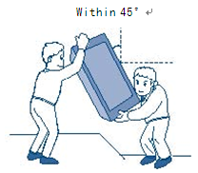
Moving the appliance
- Cut off the power supply and unplug the appliance.
- Remove all bottles from the appliance.
- When moving the appliance, do not lean the appliance over 45°.

Technical parameters
Product model | VI 59177 FS BK
Voltage/frequency | 220-240V~/50HZ
Refrigerant/weight | R600a/42g
Effective volume | 328L
Loading capacity | 126 bottles
Net weight | 75KG
Unit dimension(WxDxH) | 595×570×1770mm
Packing dimension(WxDxH) | 665×625×1960mm  With wood pallet

Remarks：
1.The net weight includes shelves and the Unit dimension is without handle on the door.
2.The manufacturer reserves all the rights to change the above parameters without prior notice. Please refer to the nameplate of your appliance.
3.Loading capacity will vary in terms of different way of bottle arrangement or different bottle sizes (standard Bordeaux with 750ml is applied here).

